Technical Specifications of Swing Gate Turnstile
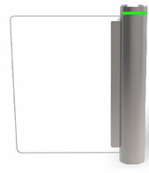
- Size : Ȼ141 x 1020mm
- Unlock time: 0.2s
- Pass rate: 35 person/min
- Pass Width: ≤600mm
- Input: 100V~240V
- Driving Voltage: 24v
- Environment: -25~70°c
- Power Consumption: 35w
- Input: 12v dry contact

